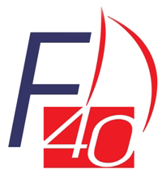 | 2018/19 FARR 40 AUSTRALIAN OPEN SERIES  NSW STATE TITLE – 2 & 3 FEBRUARY 2019  MIDDLE HARBOUR YACHT CLUB  SAIL DECLARATION

YACHT NAME: __________________________ SAIL #: ____________________________

SAIL | MANUFACTURER/YEAR | BUTTON #
Mainsail

Jib 1

Jib 2

Jib 3

Jib 4 Heavy weather *

Spinnaker MH 30

Spinnaker MH 30

Spinnaker MH 40

Spinnaker frac *

*Shall be on board at all times.

Owner/Boat representative
SIGNATURE: ______________________________ DATE: ____________________________
Received: _________________ Time: ___________________ Checked: ________________

Please return form to Farr 40 Class Administrator E: farr40australia@gmail.com

